Parameter Function Tasks
Passing parameter to functions is one of the key concepts in computer programming. The example below shows how the function square accepts a variable (referred to as inNum inside the function) and returns its square. This function is then called twice, assigning the result to variables squared and newNum respectively.
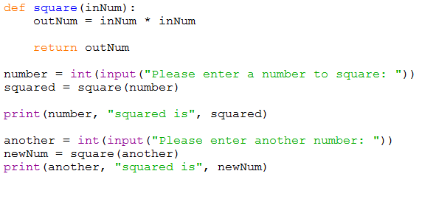

Tasks
You should write pseudocode for each task before writing the code.
- Pass an integer to a function and return that numbers times table (up to 12)
- Write a function that calculates the area of a rectangle given the length and width. Hint: Functions can accept a number of parameters providing they are separated by a comma.
- Write a function that accepts a string and a number. The string should be printed out the specified number of times.

Extension
Create a function that returns a random letter of the alphabet (A-Z)
Hint: you may require ASCII character codes. Is there a library (one of the standard functions that come with Python, such as print and random) function that converts a code to a character?

